EASTLAKE Unitized April Menu
2021
Nam id velit non risus consequat iaculis.

Chef Mikey Presents  My Kid’s Lunch  A division of Michael’s of Denver Catering  303-778-0916 | 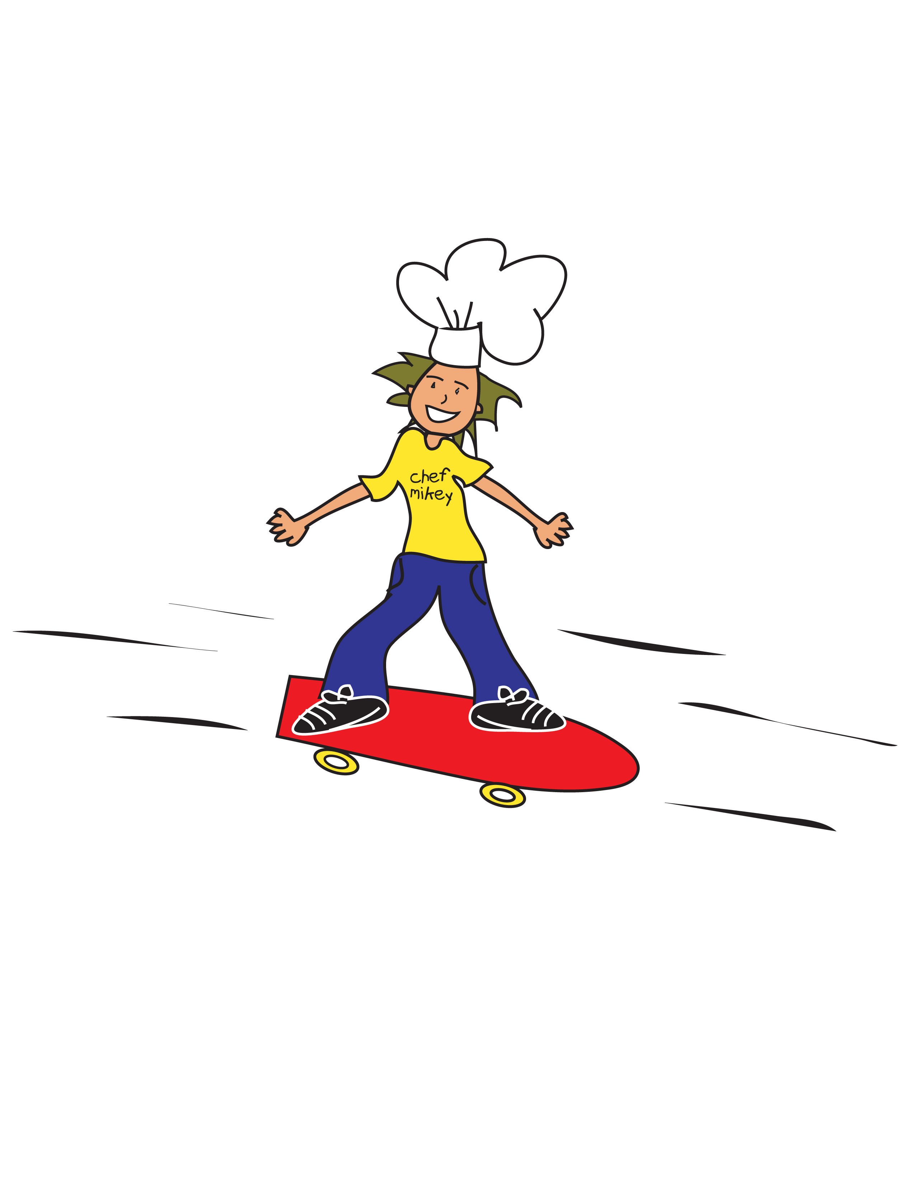

Monday | Tuesday | Wednesday | Thursday | Friday
 |  |  | 1 | 2
 |  |  | Cereal  Craisins  Grilled Cheeseburger  Wheat Bun, Ketchup  Cinnamon Apples  Baked Beans | Banana Bread  String Cheese  Applesauce  Chicken Fried Rice  Steamed Edamame  Fruit Cup
5 | 6 | 7 | 8 | 9
Cereal  Dry Fruit  Chicken Soft Tacos  Cheddar Cheese  Tortilla, Salsa  Peach Crisp  Pinto Beans | Pancakes, Syrup  100% Juice  WW Penne  Beef Meat Sauce  Steamed Broccoli  Cinnamon Apples | Lemon Poppyseed Bread  100% Juice  Chicken Nuggets & Waffles, Syrup  Dried Fruit  Home Fries | Cinnamon Roll  Banana  Beef Sloppy Joe  Wheat Bun  Steamed Corn  Whole Fruit | Zucchini Bread  Craisins  Turkey & Cheese Sandwich  Mayo&Mustard  Veggie Bag & Ranch  Banana
12 | 13 | 14 | 15 | 16
 | Chicken Sausage Biscuit  Cinnamon Pears  Chicken Patty Sandwich  Wheat Bun, BBQ Sauce  Whole Fruit  Steamed Corn | Blueberry Bread  Dry Fruit  Creamy Swedish Meatballs  Buttered Noodles  Cinnamon Apples  Steamed Peas | Waffles, Syrup  100% Juice  Turkey Hot Dog  Wheat Bun, Ketchup  Whole Fruit  Baked Beans | Pumpkin Bread  Applesauce  Teriyaki Chicken  Mixed Veggies  Steamed Rice  Dried Fruit
19 | 20 | 21 | 22 | 23
 | French Toast, Syrup  100% Juice  Penne Pasta &  Meatballs in Marinara  Steamed Green Beans  Peach Crisp | Vanilla Yogurt  Honey Granola  Blueberries  Chicken Tenders  BBQ Sauce  Buttermilk Biscuit  Steamed Corn  Fresh Banana | Cereal  100% Juice  Beef Soft Tacos  Cheddar Cheese  Tortillas, Salsa  Whole Fruit  Refried Beans | Banana Bread  String Cheese  Applesauce  Turkey & Cheese Sandwich  Mayo&Mustard  Veggie Bag & Ranch  Whole Orange
26 | 27 | 28 | 29 | 30
Pancakes, Syrup  100% Juice  Meatball Sub  Marinara Sauce  Hoagie Roll  Cinnamon Apples  Carrot Bites, Ranch Dip | Cinnamon Roll  Fruit Cup  Cheese Stuffed Breadsticks  Marinara Dipping Sauce  Steamed Peas  Whole Fruit | Lemon Poppyseed Bread  Dried Fruit  Seasoned Beef Chili  Shredded Cheddar  Homemade Cornbread  Peach Crisp  Baked Potato | English Muffin  Egg Patty  Cinnamon Pears  Chicken Mac N Cheese  Steamed Broccoli  Whole Fruit | Zucchini Bread  Applesauce  Chicken Nuggets  Buttermilk Biscuit  BBQ Sauce  Whole Orange  Baked Beans

