EASTLAKE MAY MENU
2024
Nam id velit non risus consequat iaculis.
 | Chef Mikey Presents  My Kid’s Lunch  A division of Michael’s of Denver Catering  303-778-0916 | 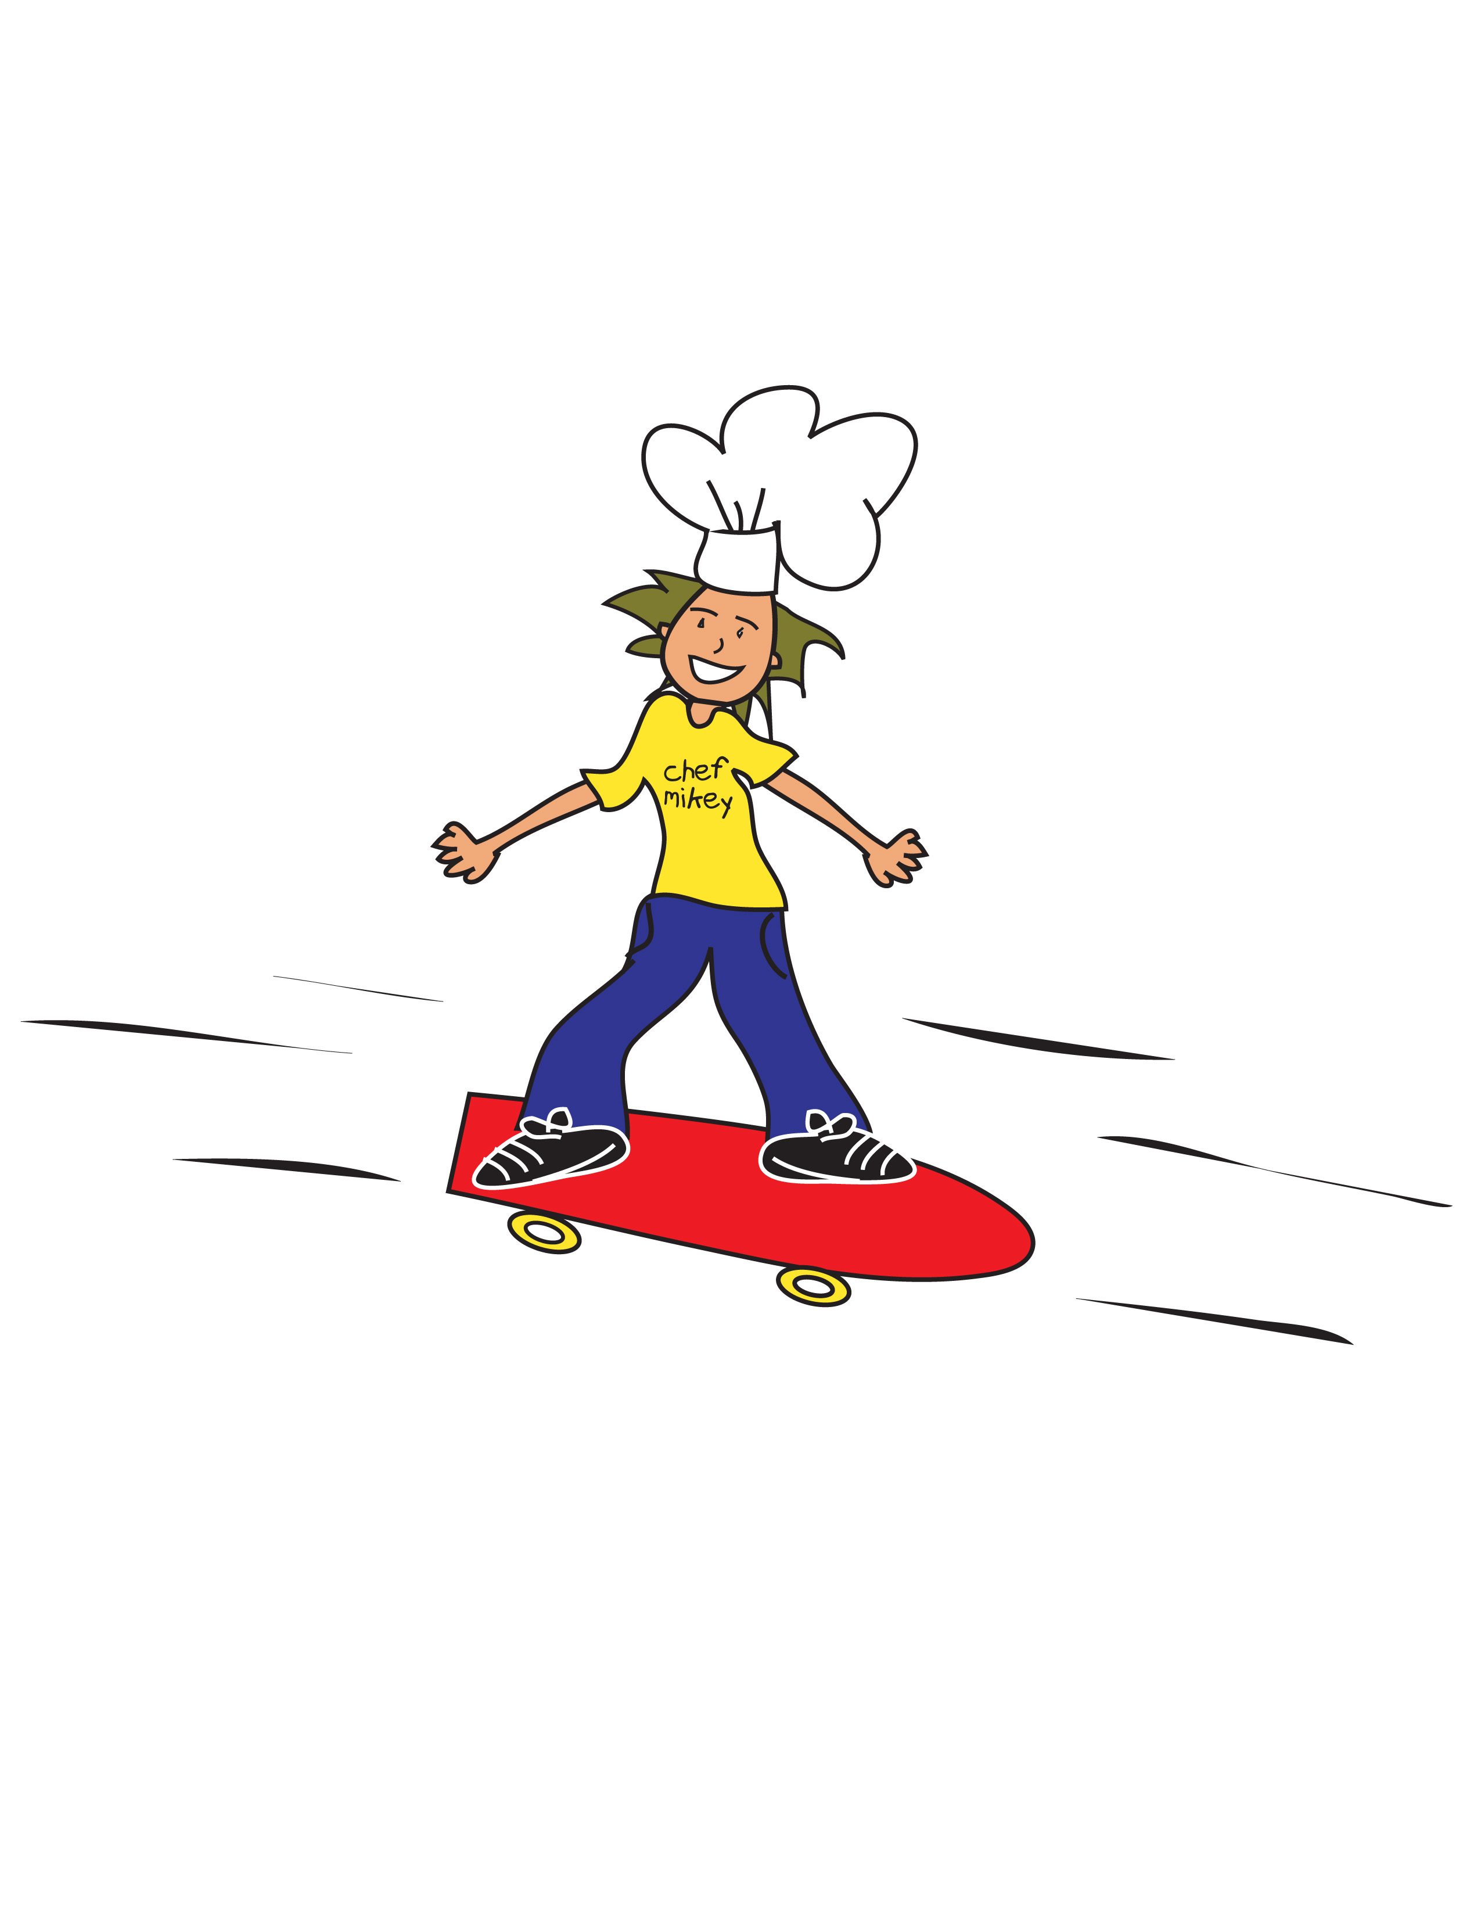

Monday | Tuesday | Wednesday | Thursday | Friday
 |  | 1 | 2 | 3
 |  | Lemon Poppyseed Bread  String Cheese  100% Juice  Fruit Cup  Meatballs in Marinara  Garlic Knot  Fresh Broccoli  Ranch Dip  Cinnamon Apples | Berry Apple Crisp Breakfast Bar(L)  Dried Fruit  Whole Banana  Crispy Chicken Sandwich  Wheat Bun, BBQ Sauce  Steamed Carrots  Strawberry Mango  Sidekick | Banana Bread  Vanilla Yogurt  100% Juice  Applesauce Cup  Orange Chicken  Brown Rice  Steamed Mixed Veggies  Fresh Banana
6 | 7 | 8 | 9 | 10
Cinnamon Toast  Breakfast Pastry  100% Juice  Whole Apple  Chicken Nuggets & Waffles, Syrup  Carrot Bites, Ranch Dip  Sliced Peaches | Cereal Bowl  String Cheese  Dried Apples  Orange  Chicken Burrito Bowl  Rice, Pinto Beans  Cheddar Cheese, Salsa  Seasonal Fruit | Blueberry Scone  100% Juice  Whole Banana  Cheese Calzone  Marinara Cup  Steamed Peas  Cinnamon Apples | Cinnamon Roll  Dried Fruit  Fruit Cup  Creamy Swedish Meatballs  Buttered Noodles  Steamed Broccoli  Cinnamon Applesauce | Apple Cinnamon Bread  Applesauce Cup  100% Juice
13 | 14 | 15 | 16 | 17
Asychronous Learning Day | S’mores Breakfast Bar(s)  100% Juice  Whole Apple  Cheese Lasagna Roll Up  Steamed Broccoli  Seasonal Fruit | Vanilla Yogurt  Honey Granola  100% Juice  Sliced Peaches  Breakfast Sandwich  Buttermilk Biscuit  Egg Patty, Cheddar Cheese  Hash Browns  Fresh Orange | Oatmeal Round  Dried Fruit  Whole Banana  Beef Soft Tacos  Cheddar Cheese  Tortillas, Salsa  Refried Beans  Fresh Apple | Pumpkin Bread  String Cheese  Applesauce Cup  100% Juice  Chicken Teriyaki  Brown Rice  Steamed Edamame  Cinnamon Apples
20 | 21 | 22 | 23 | 24
Strawberry Cinnaboli  100% Juice  Fresh Apple  Chicken Tenders  BBQ Sauce  Homemade Cornbread  Steamed Peas  Fruit Cup | Cereal Bowl  Dried Apples  Fresh Orange  Grilled Hamburger  Wheat Bun, Ketchup  Fresh Carrots  Ranch Dip  Cinnamon Apples | Lemon Poppyseed Bread  String Cheese  100% Juice  Fruit Cup  Chicken Potstickers  Ginger Soy Sauce Steamed Broccoli  Fresh Orange | Berry Apple Crisp Breakfast Bar(L)  Dried Fruit  Fresh Banana  Red Chicken Tamales  Cheddar Cheese, Salsa  Black Beans  Fresh Apple | Asychronous Learning Day
27 | 28 | 29 | 30 | 31
Memorial Day | Strawberry Crisp Breakfast Bar(L)  100% Juice  Fresh Apple  Pancakes, Syrup  Sausage Patty  Hash Browns  Fresh Banana | Blueberry Scone  100% Juice  Fresh Banana  Bean & Cheese Pupusa  Salsa  Refried Beans  Cinnamon Applesauce | Cinnamon Roll  Dried Fruit  Fruit Cup  Chicken Parm Sandwich  Marinara, Parmesan  Wheat Bun  Steamed Broccoli  Fresh Apple | Apple Cinnamon Bread  Applesauce Cup  100% Juice  Macaroni & Cheese  BBQ Chicken  Steamed Carrots  Seasonal Fruit
*This institution is an equal opportunity provider.**All meals are served with a choice of 1% or skim white milk. Chocolate milk is offered on Fridays.
***This menu is subject to change based on item availability. ****Shelf stable meal kits available upon request.
Our menu items may contain milk, eggs, wheat, soy, sesame, fish or shellfish.

